Lab 15: Implementing Common Protocols and

Services for Basic Security Practice

1. Protecting Sensitive Data
   1. Load Lab Configuration
2. Access the UbuntuSRV VM
3. Login with credentials provided
4. Launch Firefox
5. In the Firefox web browser, type 172.16.1.1 into the address bar and click enter
6. Log in with the pfSense login page with credentials provided.
7. On the top menu navigate to system > package Manager
8. Verify the Installed packages make sure that you can see the squid and squidguard packages are installed

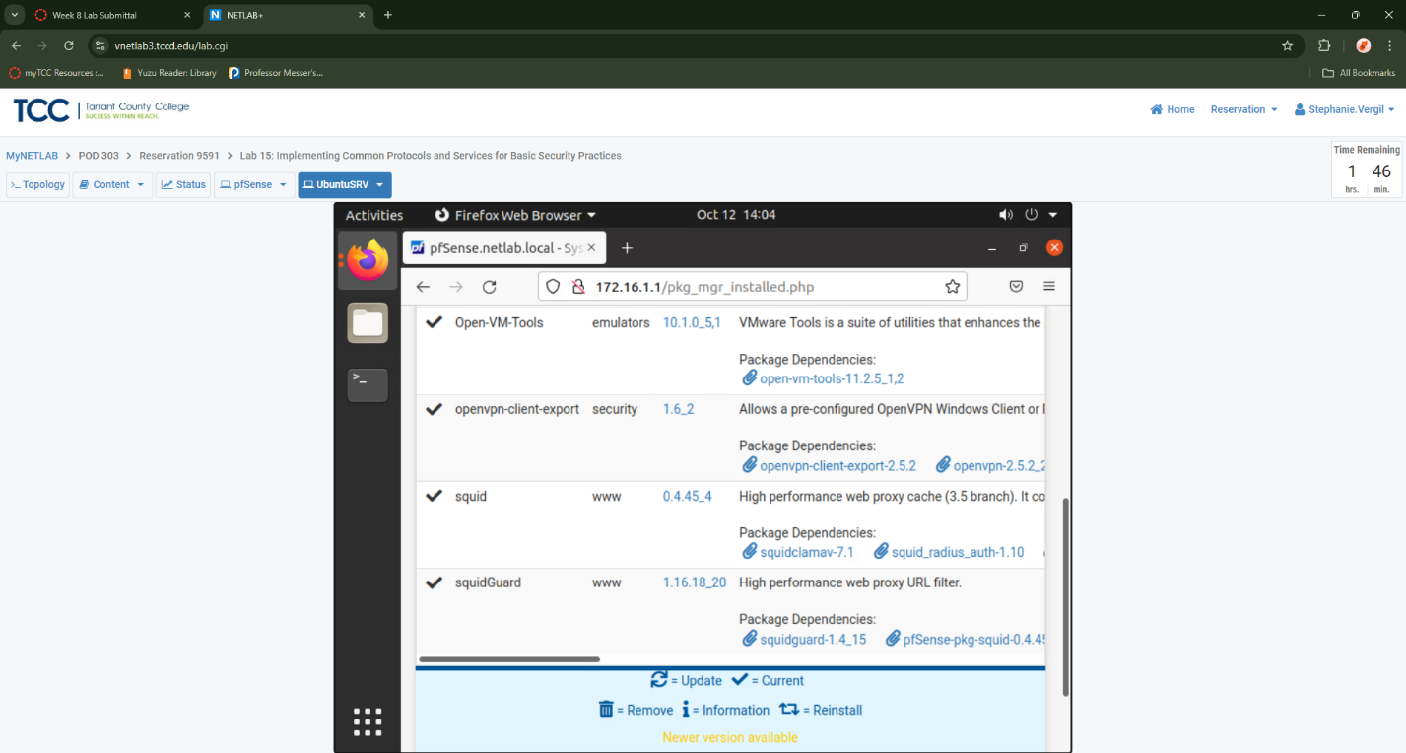

1. Once verified, navigate to Services > Squid Proxy Server.
2. First, click on the Local Cache, then scroll down to find and set the Hard Disk Cache Size to 50.

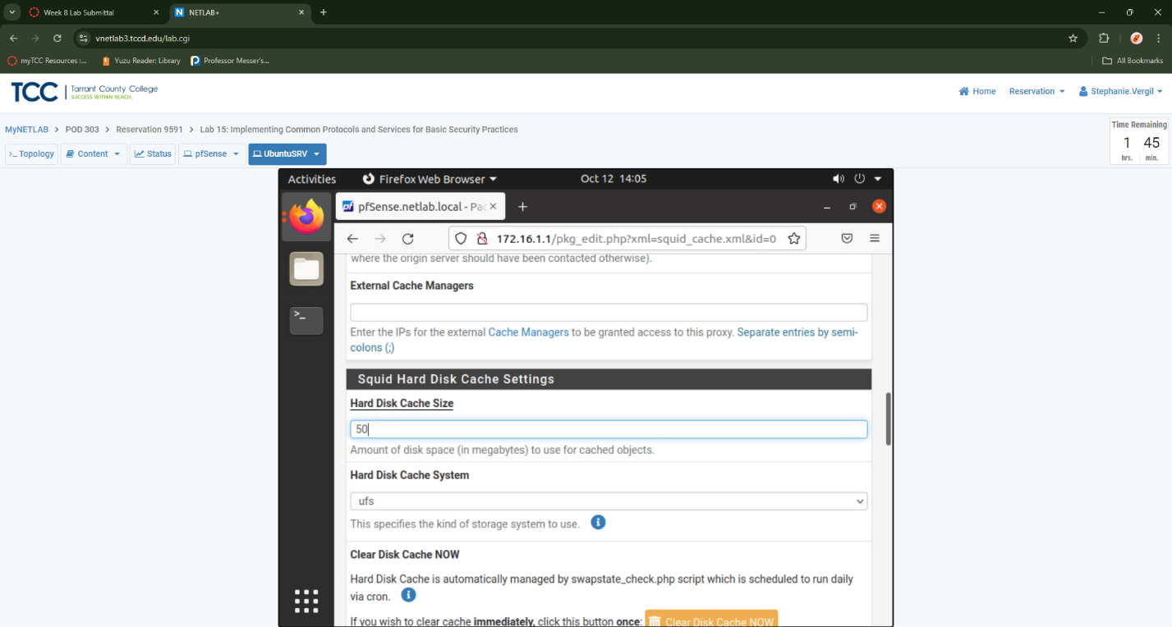

1. Scroll to the bottom of the page and click Save. The page will refresh and bring you back to the top after it is saved.
2. Then, click on the General tab and check the checkbox to Enable the Squid Proxy.

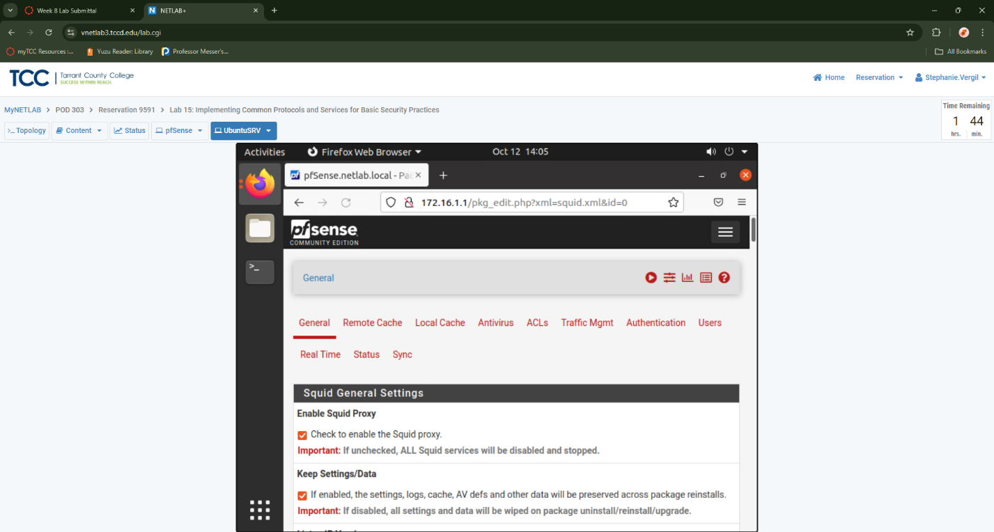

1. Select LAN and DMZ for the Proxy interface. To do so, hold the CTRL key and select each entry until both are highlighted
2. Use port number 3128 as the Proxy port.

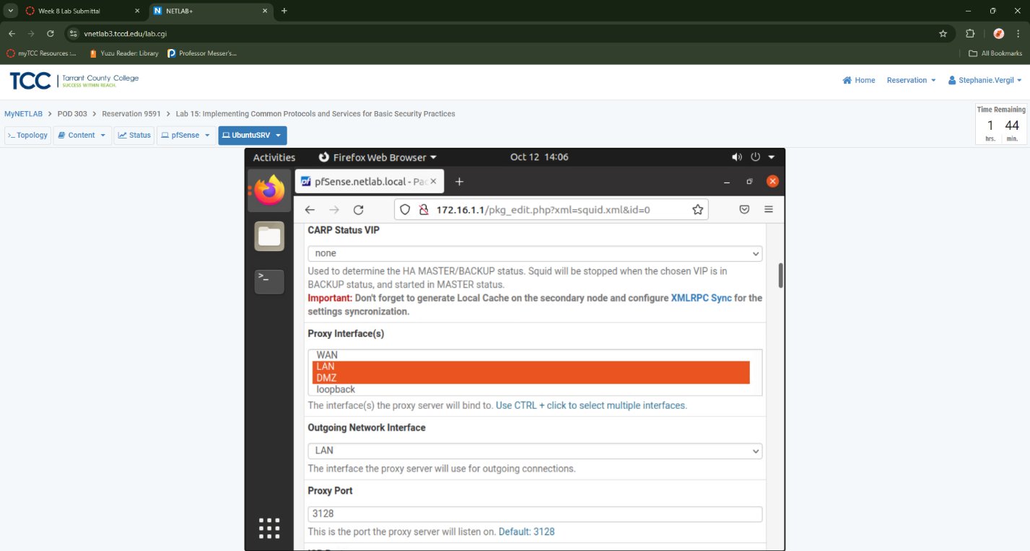

1. Uncheck the checkbox next to Allow users on interface.

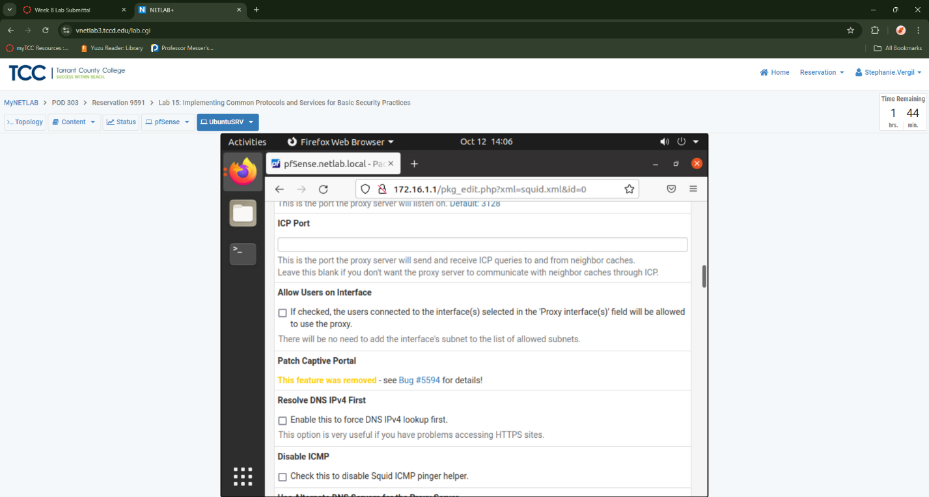

1. Check the checkbox next to Transparent proxy to enable this feature.

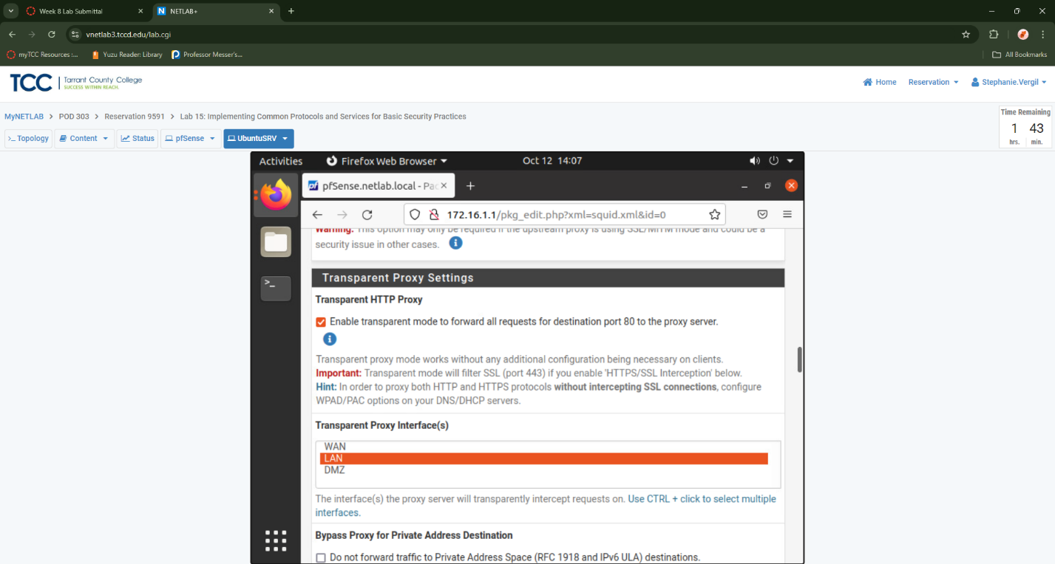

1. Scroll down until you see the Enabled Access Logging entry. Check the checkbox to enable.
2. Verify that the Log store directory is configured to /var/squid/logs.
3. Type the number 7 as the value for the Rotate Logs field.

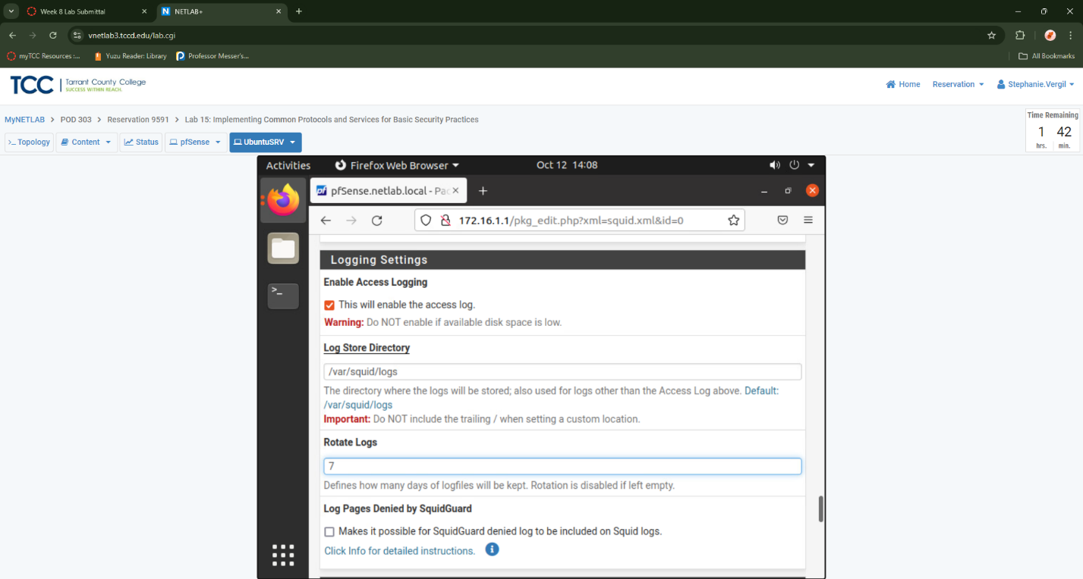

1. For Visible Hostname, type proxy.pfsense.
2. For the Administrator Email, type [pfproxy@mail.netlab.local](mailto:pfproxy@mail.netlab.local)

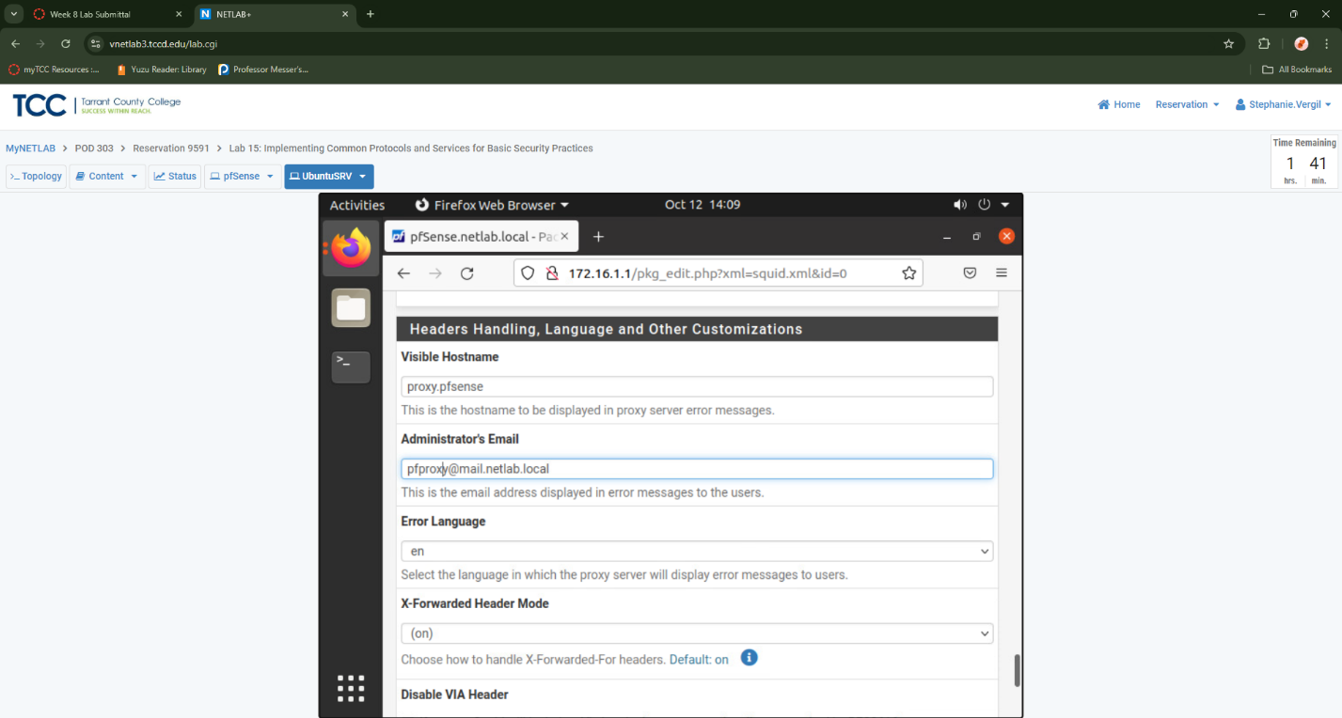

1. Scroll to the bottom of the page and click Save.
2. Next, click on the ACLs tab. Enter the subnets mentioned below into the Allowed subnets field. 192.168.0.0/24 172.16.1.0/28

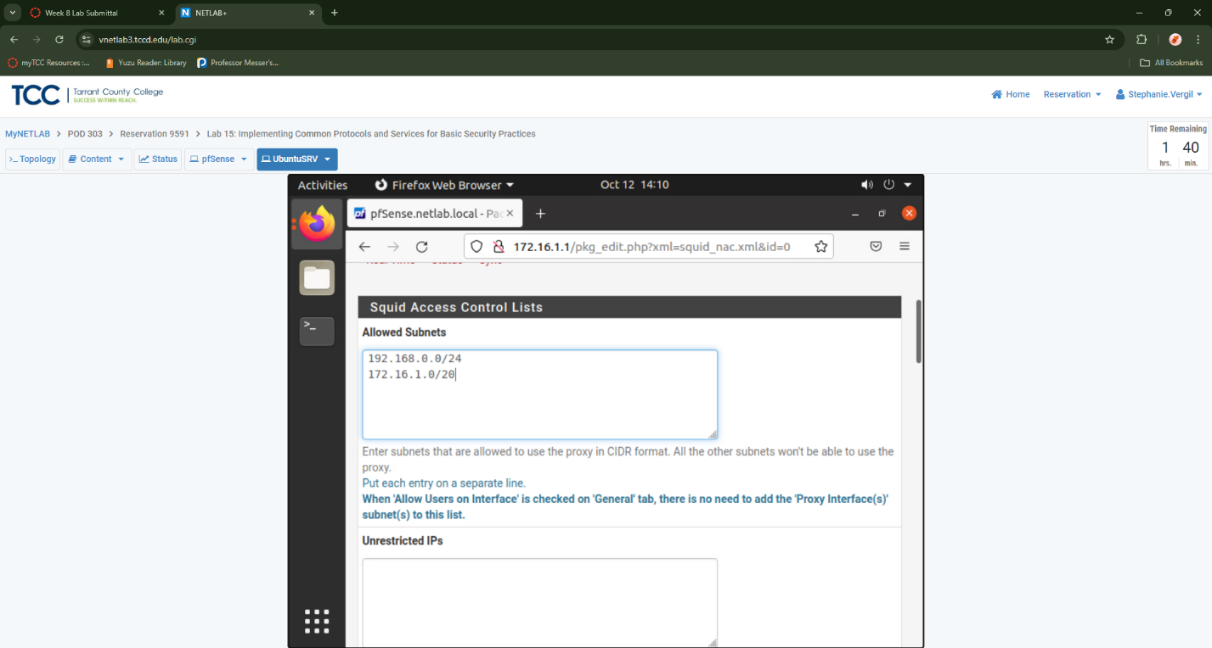

1. Scroll towards the bottom of the page until you see ACLl Safeports. Type 80 and 443 into the text field with a space inbetween.
2. Type 443 for ACL SSLlports.

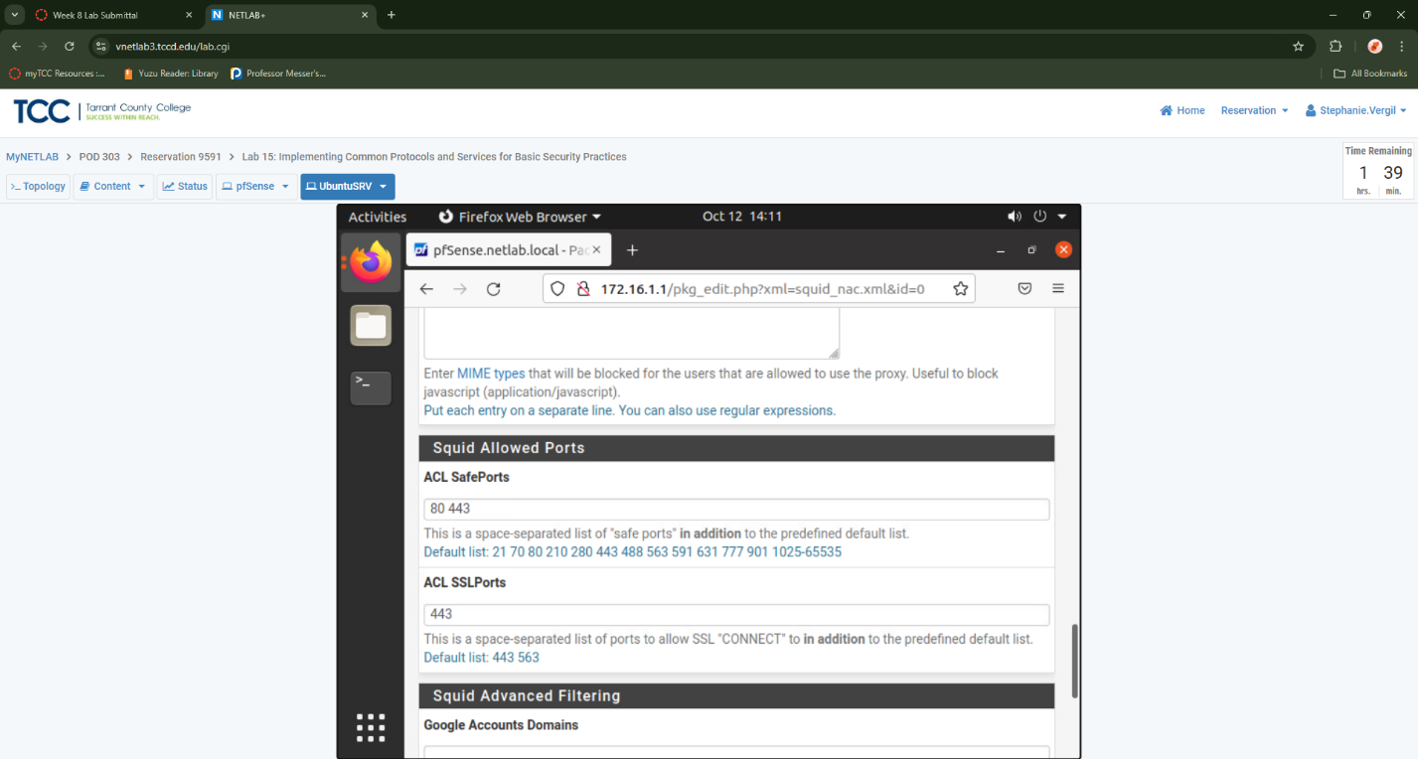

1. Click the Save button
2. Click on the Traffic Mgmt tab. For Maximum Download Size, enter the value 500000 to represent 500MB as the maximum download file size.
3. For Maximum Upload Size, enter the value 50000 to represent 50MB as the maximum upload file size.

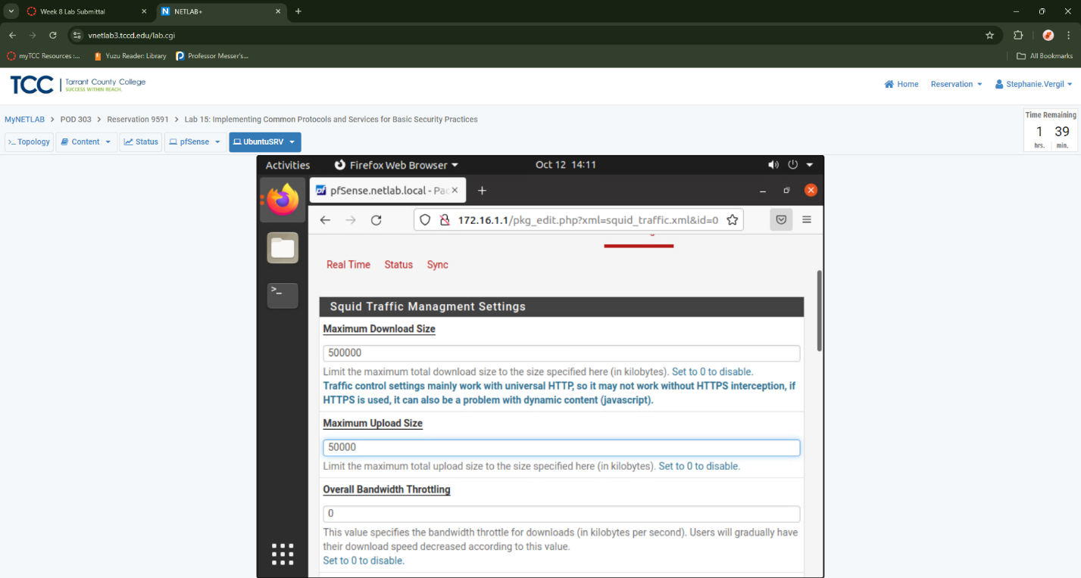

1. Scroll to the bottom and click the save button.
   1. Configuring SquidGuard
2. While on the pfSense web configurator, navigate to Services > SquidGuard Proxy filter.
3. On the General settings tab, check the checkbox next to Enable.

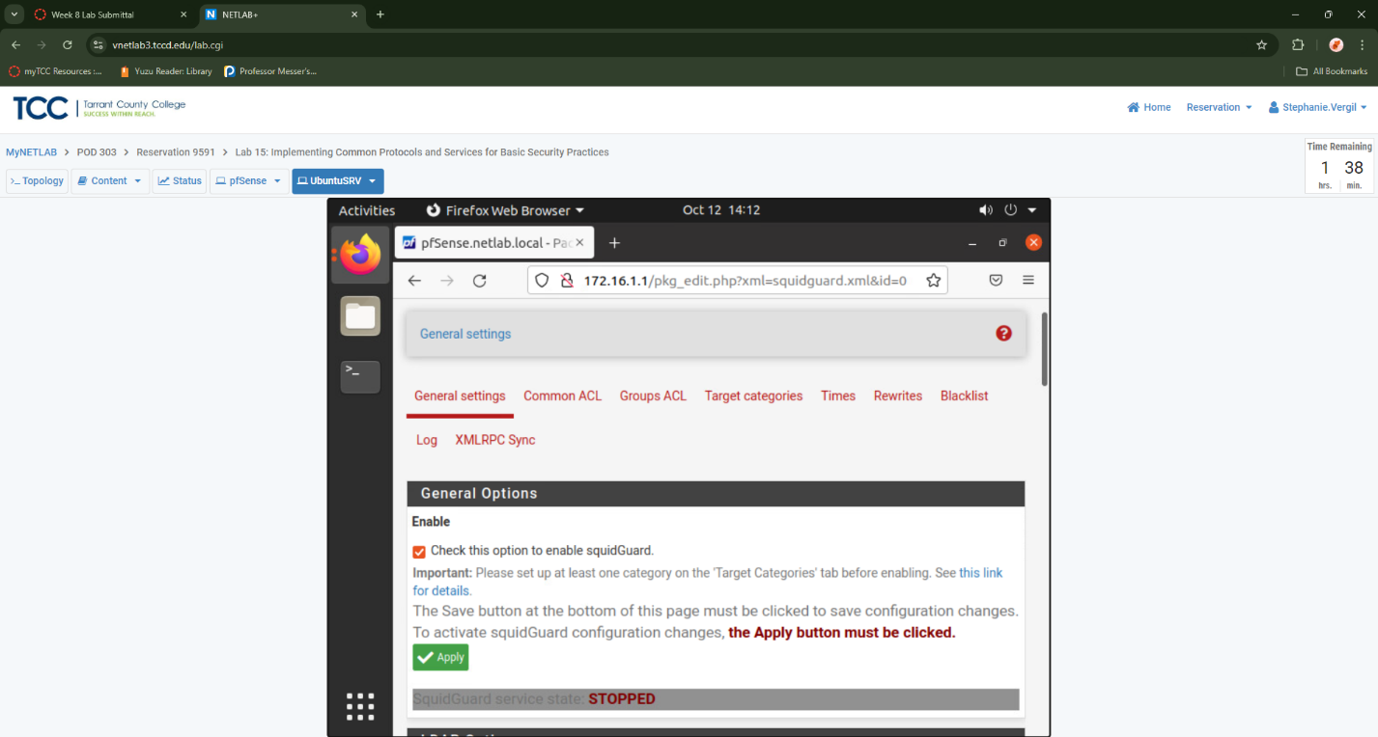

1. Scroll down until you see Enable GUI log. Check the checkbox to enable this feature
2. Check the box next to Enable log.

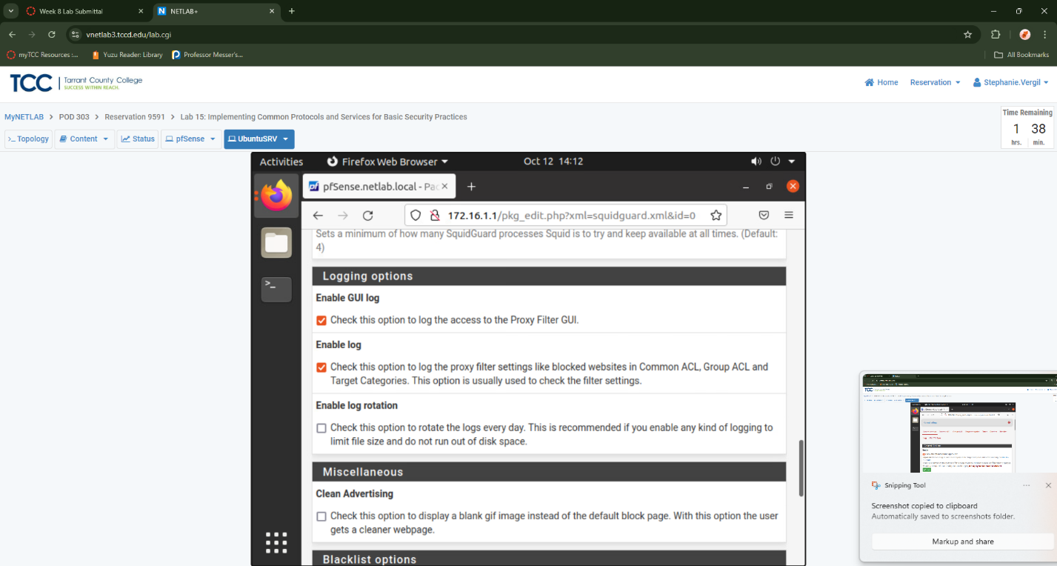

1. Scroll to the bottom of the page and click the Save button.
2. Once the page reloads, click the Apply button located towards the top of the page.

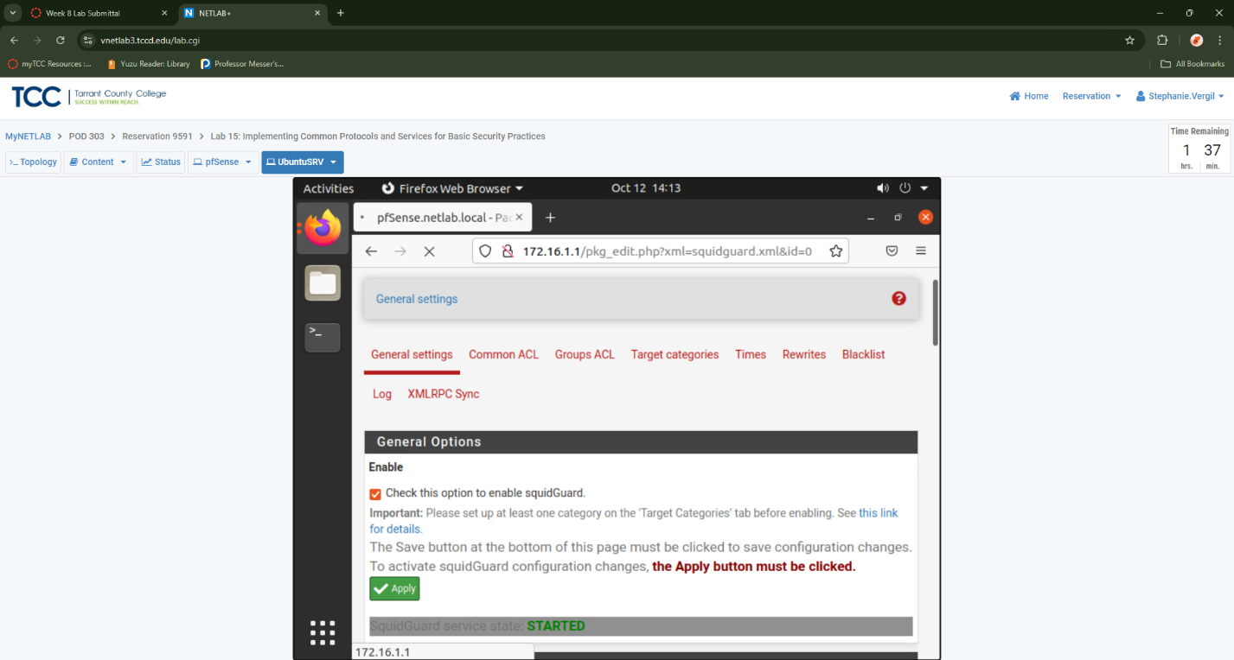

1. Next, click on the Target categories tab. Click the Add a new item icon.
2. For the Name, type Blist1.
3. For Order, select the dropdown box and choose --- Last ---.
4. Type casino.com into the whitespace area for Domain List.

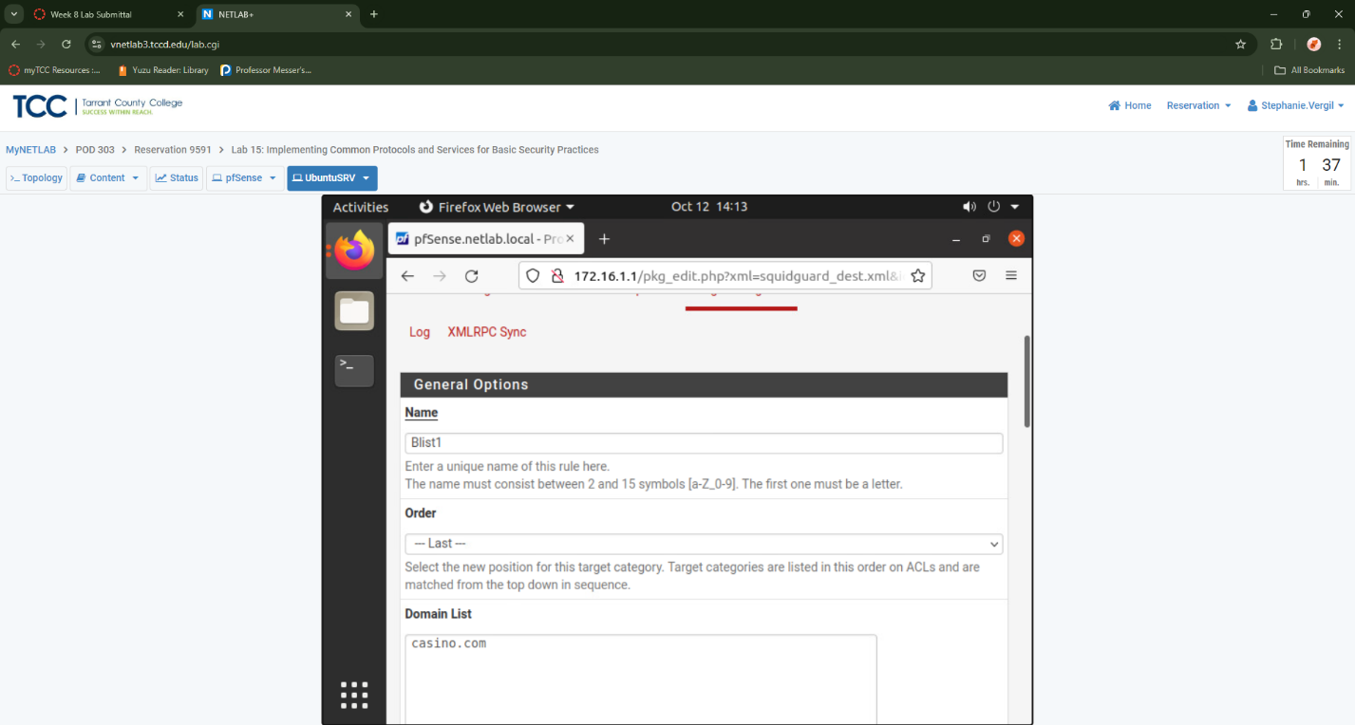

1. Type casino into the whitespace area next to Regular Expression

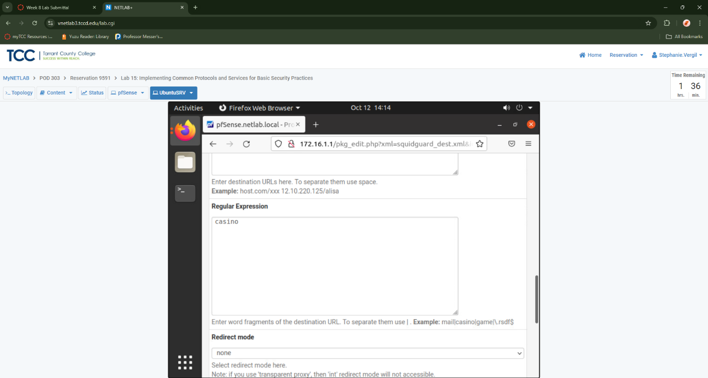

1. Select the dropdown box next to Redirect mode and choose int error page (enter error message)

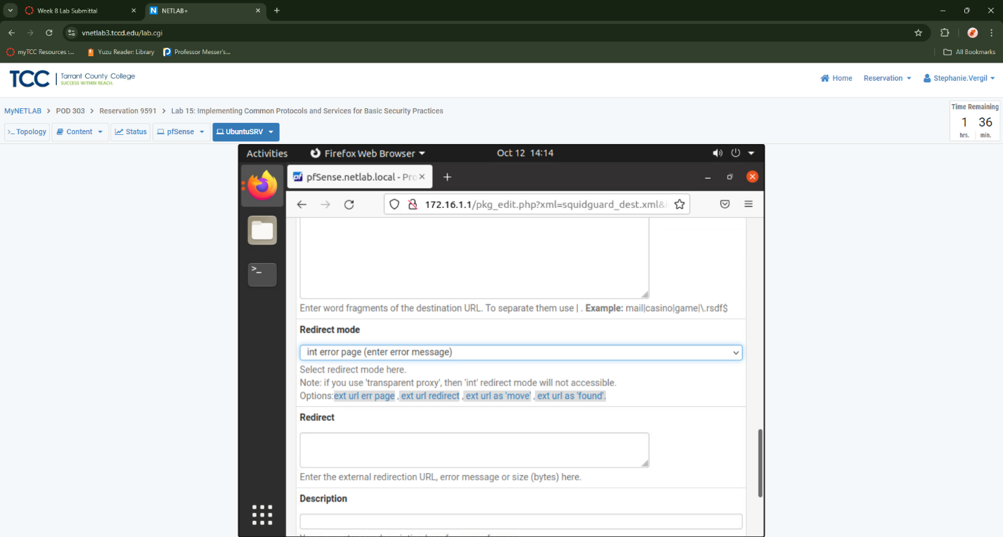

1. Check the box next to the Log entry to enable logging for the ACL

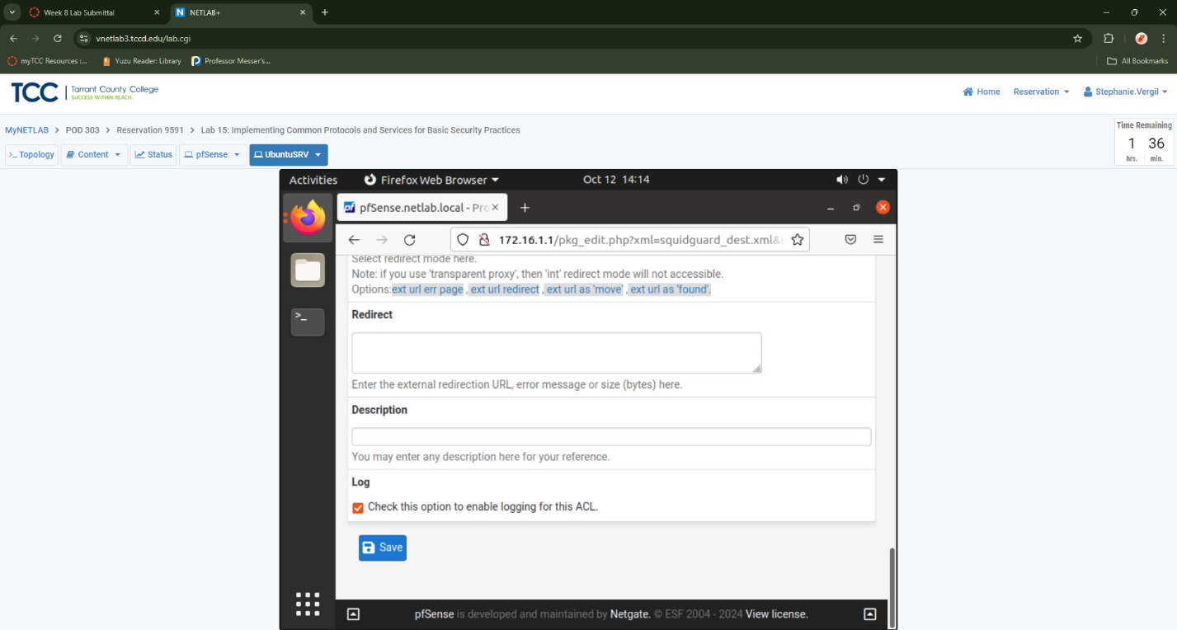

1. Click the Save button.
2. Click on the Common ACL tab. Click the Show rules icon within the Target Rules List pane.
3. Notice Blist1 is added to the list. For this entry, select the access dropdown box and choose deny. Click the dropdown box entry for Default access [all] and select allow.
4. Within the whitespace area for the Proxy Denied Error, type Request denied by the XYZ Security proxy.
5. Select the dropdown box next to Redirect mode and choose int error page (enter error message)

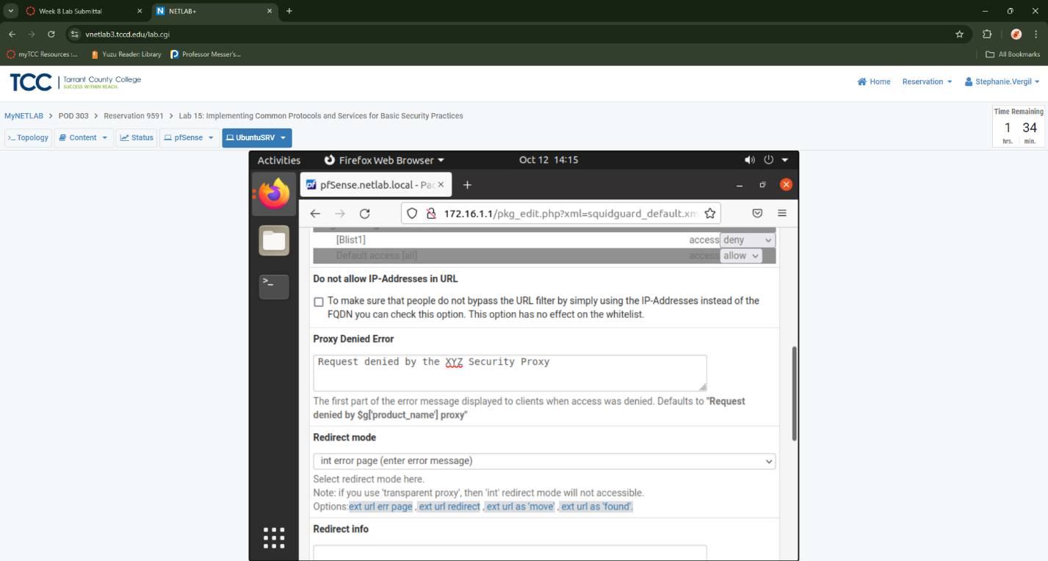

1. Check the box next to Log.

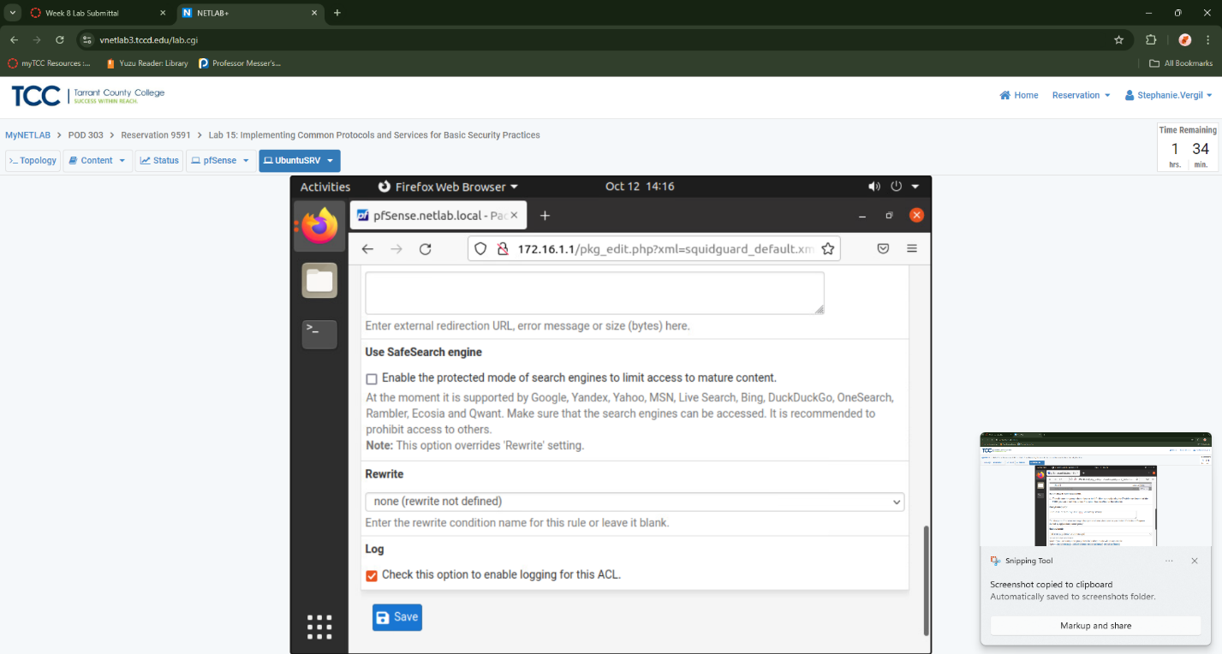

1. Save
2. Once the page refreshes, click the General settings tab
3. Scroll to the bottom and click the Save button
4. To apply all configurations, click the Apply button.
5. Verify that the SquidGuard service state is STARTED.

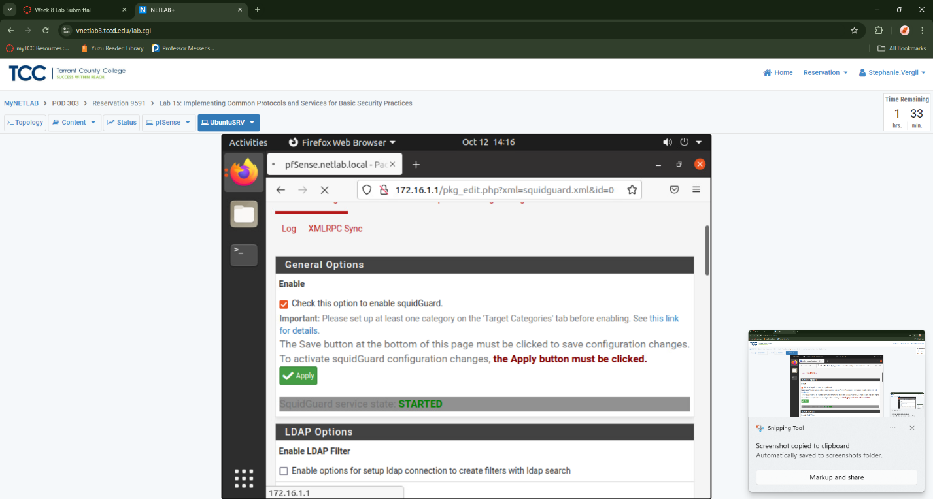

* 1. Configure & Test Firefox Proxy Settings

1. While on the Firefox web browser, click the Application Menu icon located in the top-right corner, followed by clicking on the Settings icon.
2. Scroll down to the bottom in the Settings tab and click on the Settings… button.
3. A pop-up window appears. Select the radio button for Manual proxy configuration. Type 192.168.0.1 as the HTTP Proxy and 3128 as the Port. Check the checkbox for Also use this proxy for FTP and HTTPS

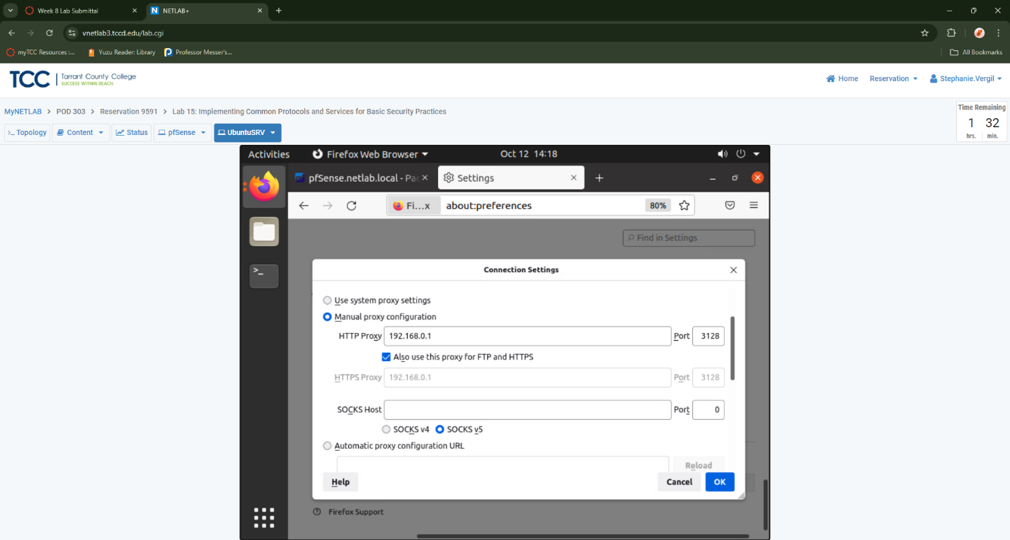

1. Back on the Firefox Preferences window, close the Settings tab.
2. Open a new tab in Firefox by clicking the “+” icon located at the top. Type casino.com into the address field followed by pressing Enter. Notice the traffic will be dropped due to the rule we added

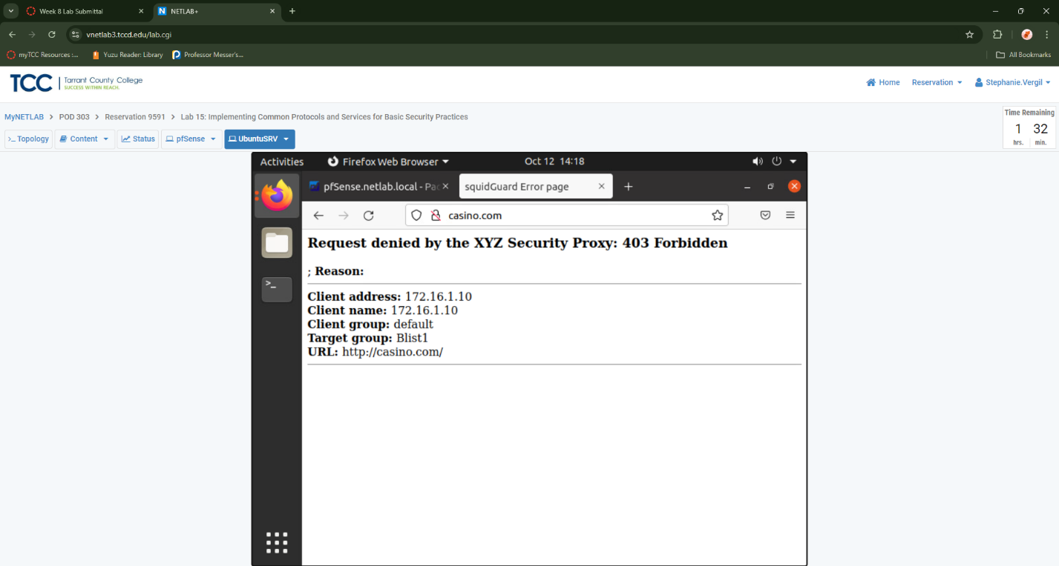

1. Close the web browser
2. Leave the UbuntuSRV window open to continue with the next task.

2 Configuring and Enabling SSL for HTTP Services

2.1 Generating a Server Key and Server Certificate

1. While on the Ubuntu system, open a new terminal window by clicking on the terminal icon located on the left menu pane
2. Create a new directory by typing the command followed by pressing the Enter key.
3. Change to the newly made directory.
4. Verify that OpenSSL is installed on the system.
5. Type the following command to generate an RSA server key. When prompted for a passphrase, type NDGlabpass123! followed by pressing the Enter key. When prompted once more, type NDGlabpass123! again. Press Enter.

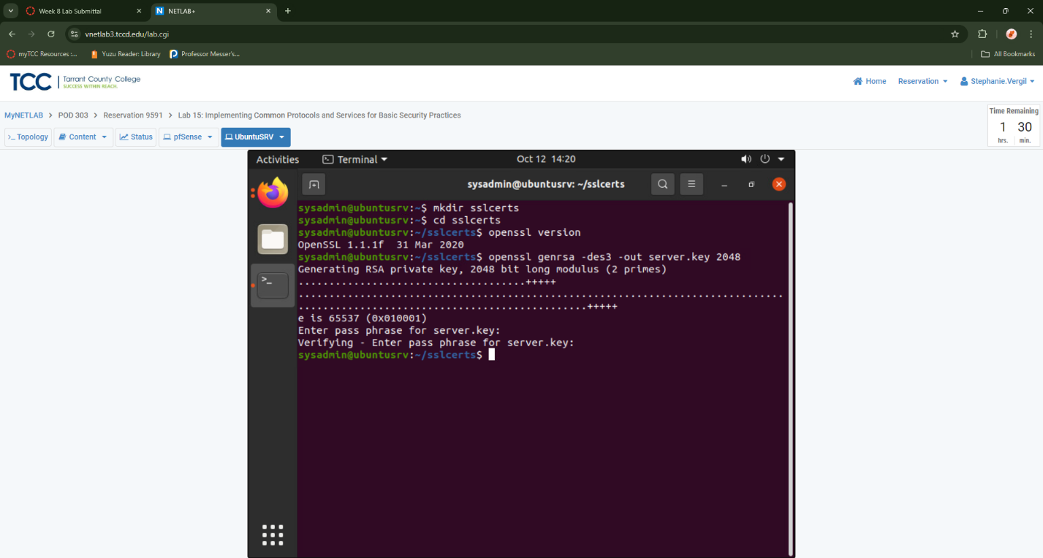

1. Verify that the server.key has been generated. By entering the following command ls -l
2. Generate the Certificate Signing Request (CSR) with the new server.key. sysadmin@ubuntusrv:~$ openssl req -new -key server.key -out server.csr a. When prompted for the server.key pass phrase, type NDGlabpass123!. Press Enter. b. During the signing request process, a series of questions will be asked. Type the information given below for each step, followed by pressing Enter. i. Country Name: US ii. State Name: TX iii. Locality Name: Austin iv. Organization Name: XYZ Security v. Organizational Unit Name: Press Enter vi. Common Name: ubuntusrv.netlab.local vii. Email: Press Enter viii. Challenge Password: Press Enter ix. Company Name: Press Enter

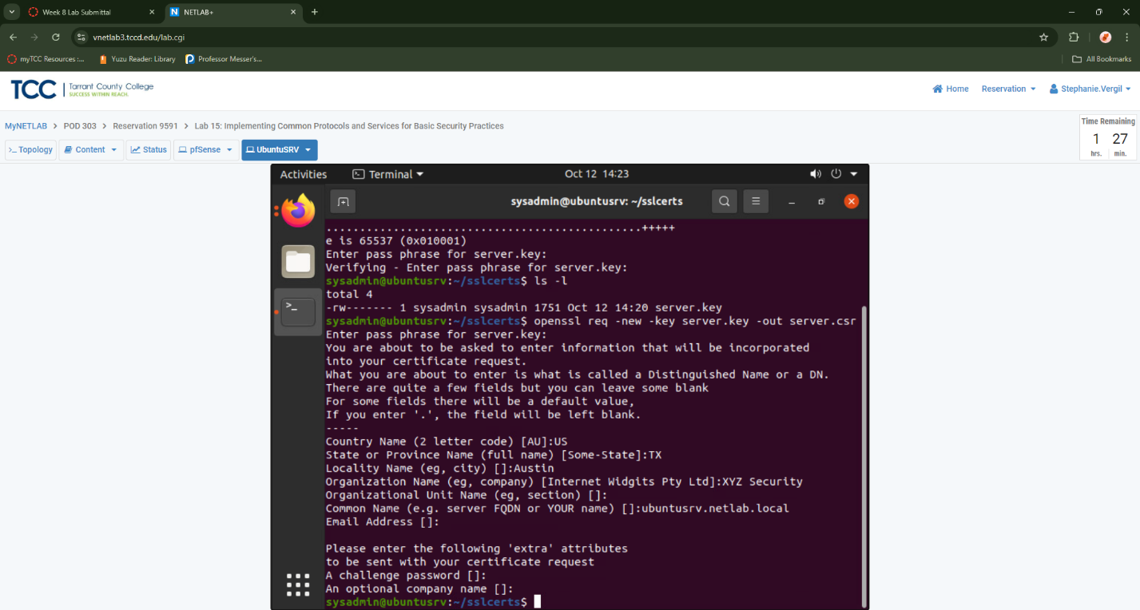

1. Once completed with the wizard, verify that server.csr has been created
2. Sign the server.csr to create a server.crt file. When prompted for the passphrase, type NDGlabpass123! followed by pressing Enter. sysadmin@ubuntusrv:~$ openssl x509 -req -days 365 -in server.csr -signkey server.key -out server.crt
3. Verify that the new server.crt has been created.

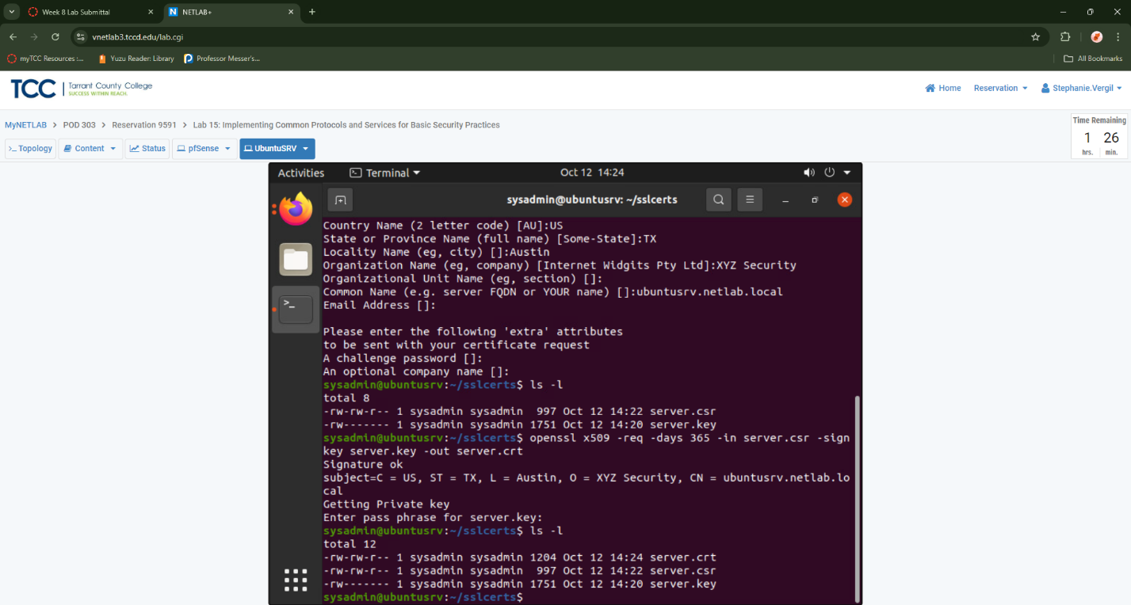

1. View the contents of the newly created server.crt certificate. sysadmin@ubuntusrv:~$ openssl x509 -in server.crt -noout -text

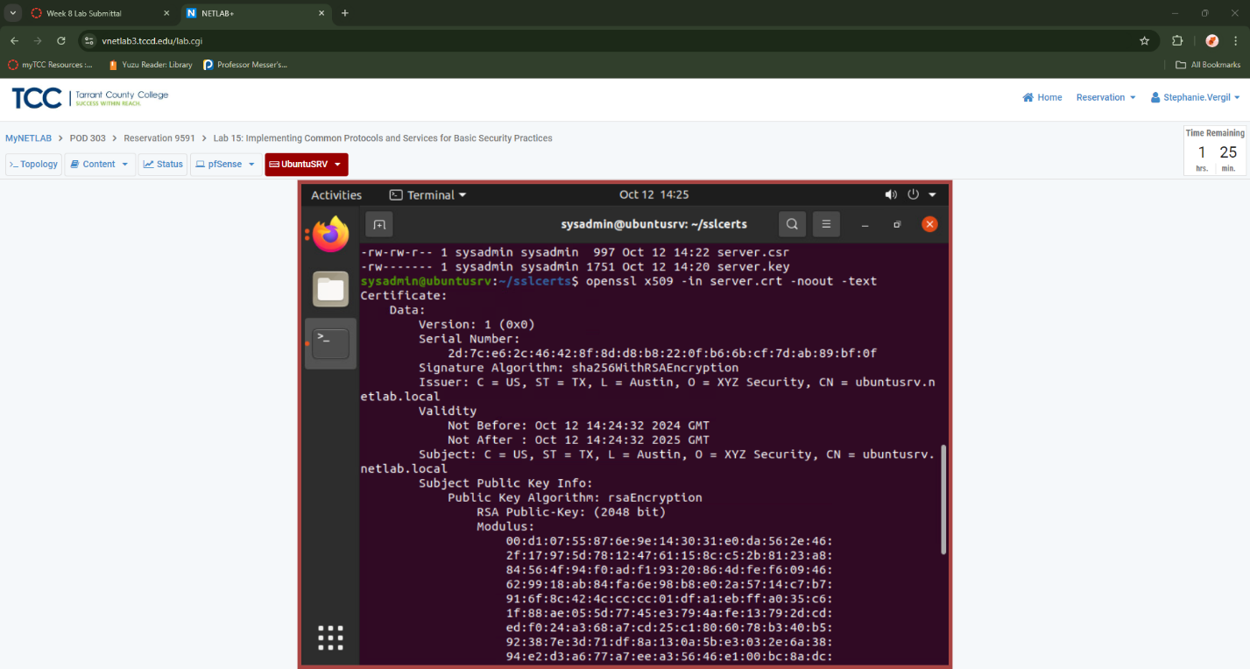

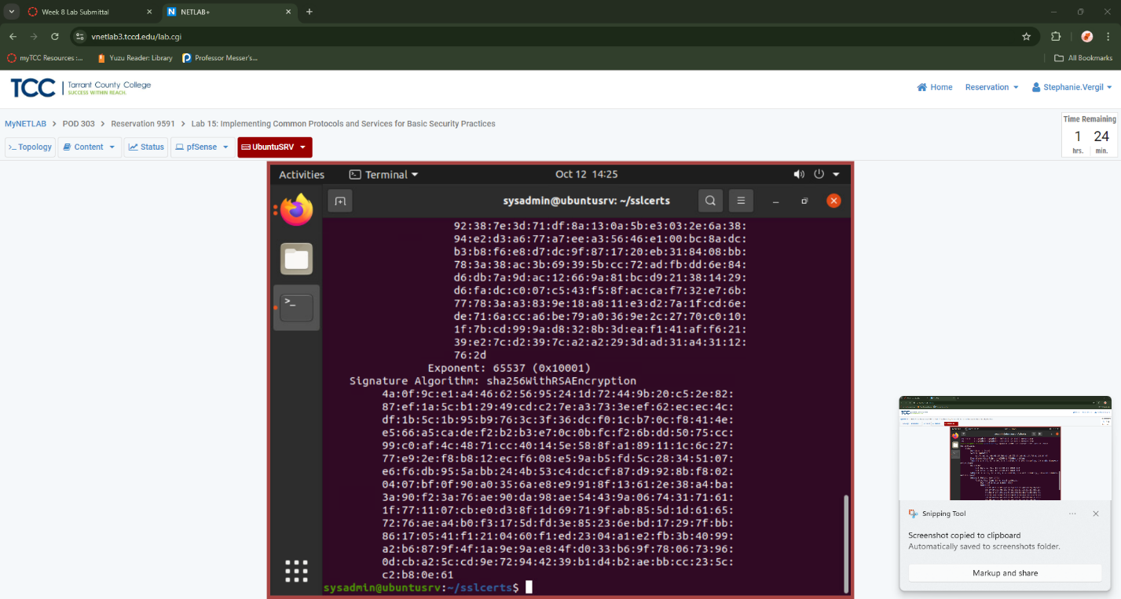

2.2 Configure Apache to Utilize SSL

1. Create a new directory that will act as a placeholder for the SSL objects. If prompted for password, enter NDGlabpass123!.
2. While in the /sslcerts directory, generate the same server.key but with no passphrase requirement. When prompted for a password for the server.key file, enter NDGlabpass123!. sysadmin@ubuntusrv:~$ openssl rsa -in server.key -out server.key.nopass
3. List the current files in the directory. You should now have four different files.
4. Copy the server.key.nopass to the /etc/apache2/ssl_certs directory. If prompted for a password, enter NDGlabpass123!. sysadmin@ubuntusrv:~$ sudo cp server.key.nopass /etc/apache2/ssl_certs
5. Copy the server.crt file to the /etc/apache2/ssl_certs directory. If prompted for a password, enter NDGlabpass123!. sysadmin@ubuntusrv:~$ sudo cp server.crt /etc/apache2/ssl_certs
6. Change to the /etc/apache2/ssl_certs directory.
7. Verify that two files are present in the directory.

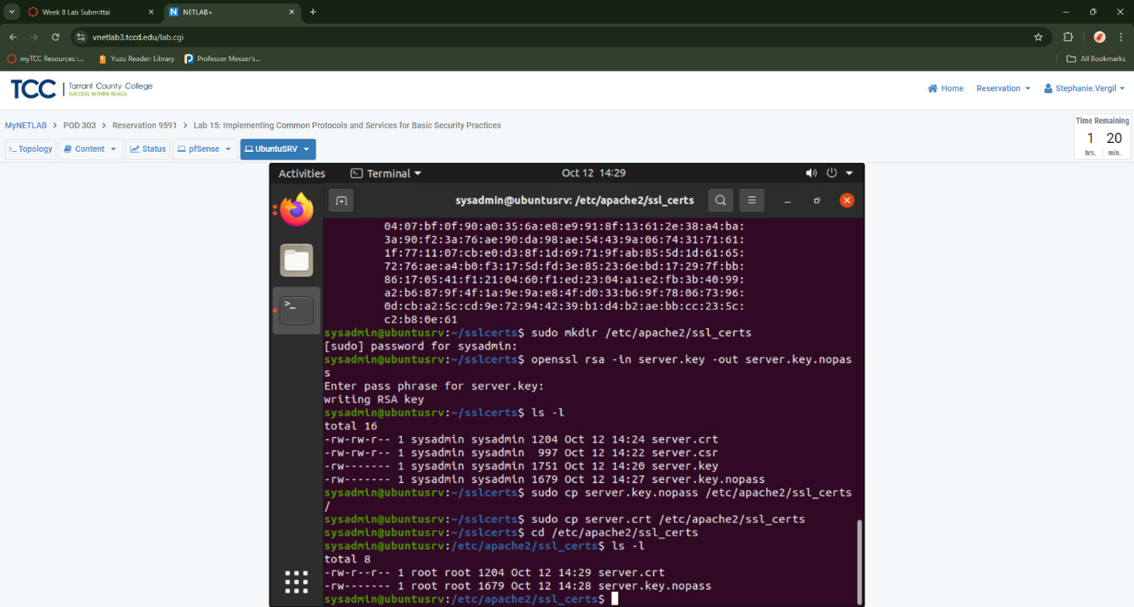

1. Rename the server.key.nopass file to server.key. If prompted for a password, enter NDGlabpass123! Enter the following command: sudo mv server.key.nopass server.key
2. We already have an nginx server running, but since it is used for regular service, we will use the Apache web service for this lab instead. First, type sudo service nginx stop to disable the nginx server. If prompted for a password, type NDGlabpass123!

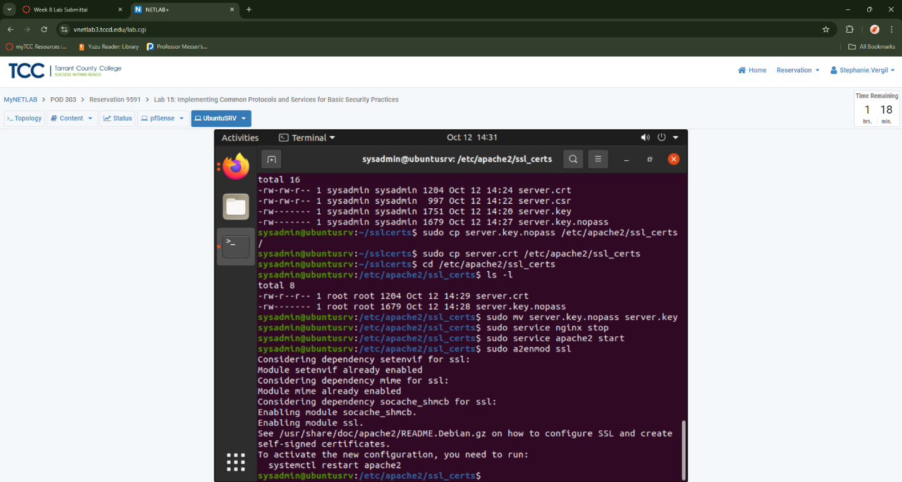

1. Then type sudo service apache2 start to start the Apache service.
2. Initiate the a2enmod module for SSL. Then, restart the apache2 service. If prompted for a password, type NDGlabpass123!. Enter the following command sudo a2enmod ssl and sudo service apache2 restart
3. Create a new symbolic link to the default-ssl.conf file. If prompted for a password, type NDGlabpass123!. If you receive an error stating that the file already exists, remove the old 000- default.conf file using the rm command and enter the ln command below again. sysadmin@ubuntusrv:~$ sudo ln –s /etc/apache2/sites-available/default-ssl.conf /etc/apache2/sites-enabled/000-default-ssl.conf
4. Verify that a Virtual Host is configured in the default sites-available file. Type the command below to open the file with the nano text editor. If prompted for a password, type NDGlabpass123! . sysadmin@ubuntusrv:~$ sudo nano /etc/apache2/sites-available/000-default.conf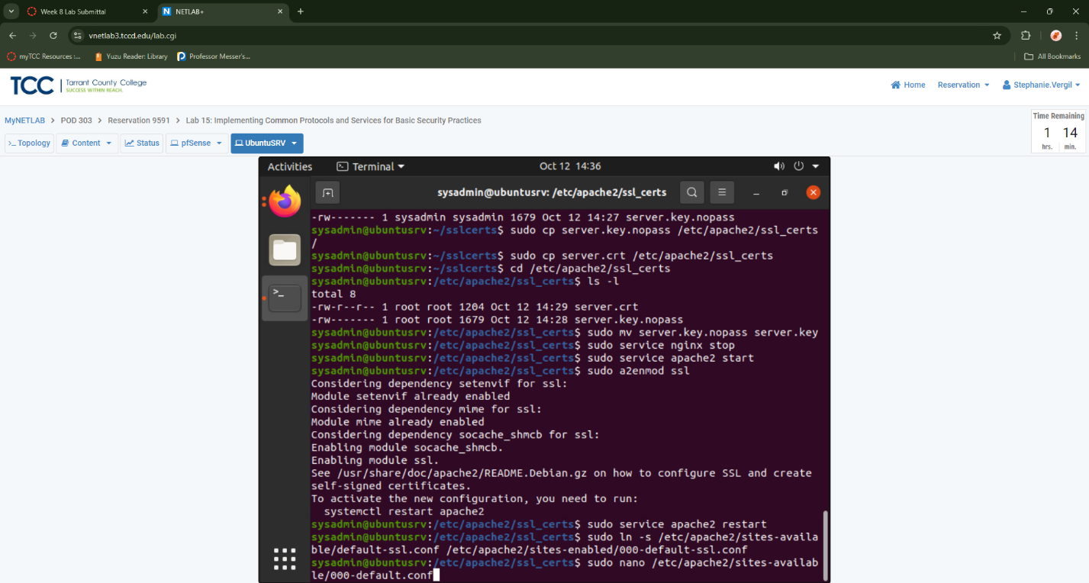
5. When in the nano editor, confirm that the ServerName is set to 172.16.1.10:80. Then check other settings, if you see any missing entries, enter the same as shown in the screenshot below. Once finished, press CTRL+S to save, and CTRL+X to exit.

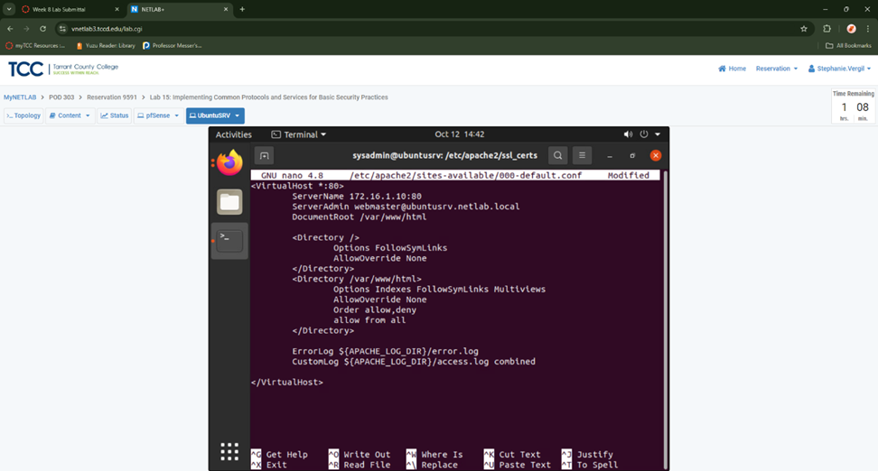

1. Next, edit the contents of the default-ssl file. Type the command below followed by pressing Enter. If prompted for a password, type NDGlabpass123!. Enter the following command: sudo nano /etc/apache2/sites-available/default-ssl.conf
2. Add the missing information as you did before. Use the arrow keys to position the cursor.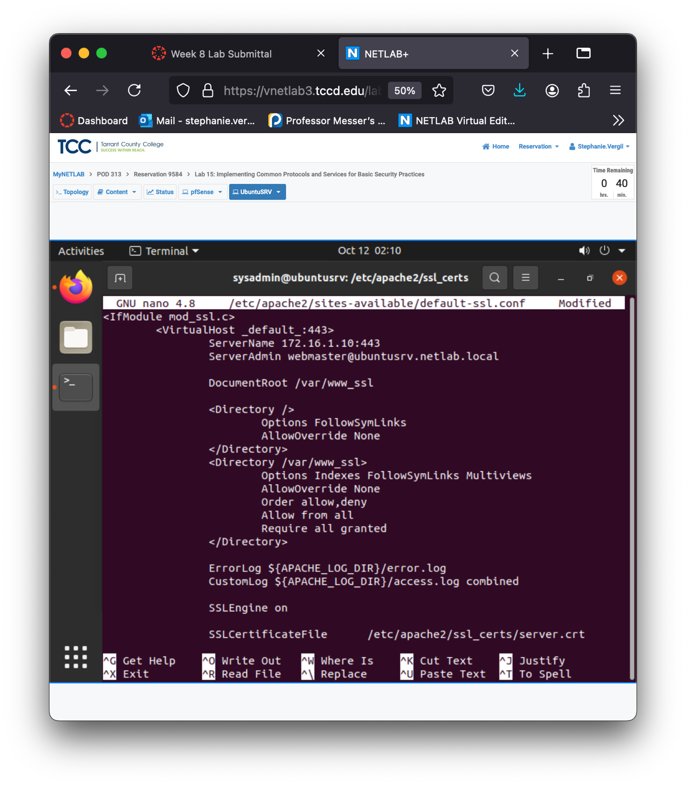

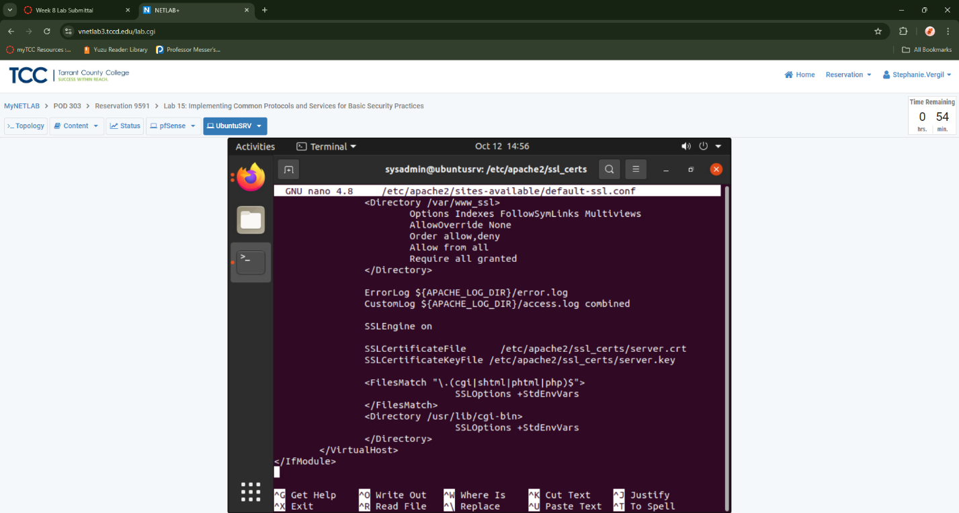

1. Press CTRL + S to save, and CTRL+X to exit.
2. Create a new directory. Enter the following command: sudo mkdir /var/www_ssl
3. Leave the Terminal open for the next section

2.3 Configuring & Testing HTTPS Test Page

1. While on the Terminal, navigate to the /var/www_ssl directory. Entering the following command cd /var/www_ssl
2. Create a new index.html file. Enter the following command: sudo nano index.html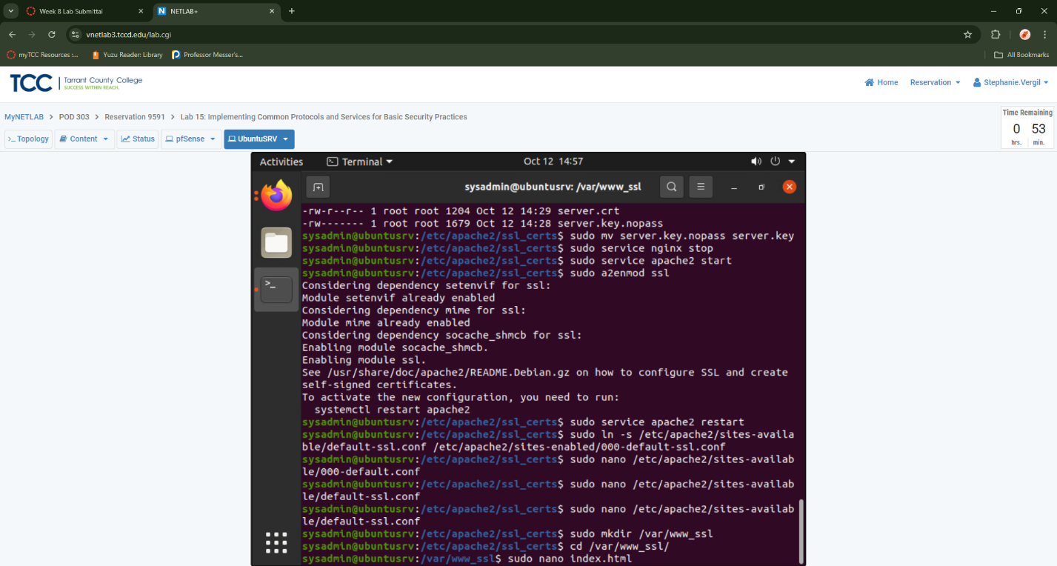
3. Within the nano text editor, type the HTML code below.

<html>

<body>

<h1>Testing HTTPS Service</h1>

</body>

</html>

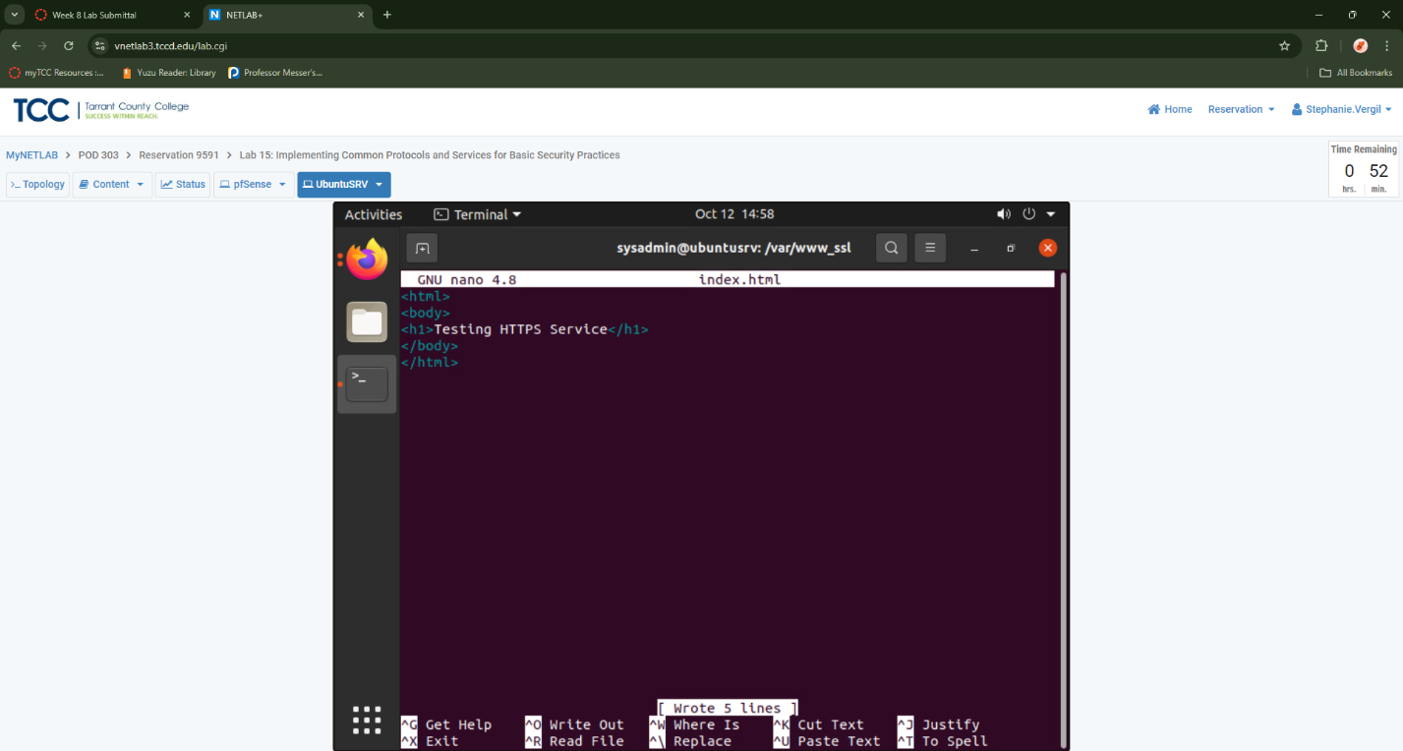

1. Press CTRL + S to save, and CTRL+X to exit.
2. Restart the Apache web service to apply all the configuration changes made. If prompted for a password, enter NDGlabpass123!. Enter the following command: sudo service apache2 restart
3. Open a new Firefox web browser by clicking the Firefox icon located on the left menu pane.
4. Go back to Firefox settings and switch to use system proxy settings.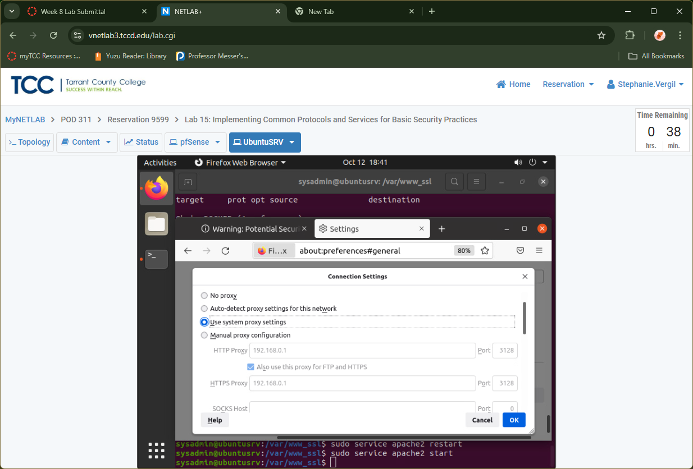
5. Within the address bar, type https://172.16.1.10. Press Enter.
6. When presented with the Warning page, click on Advanced….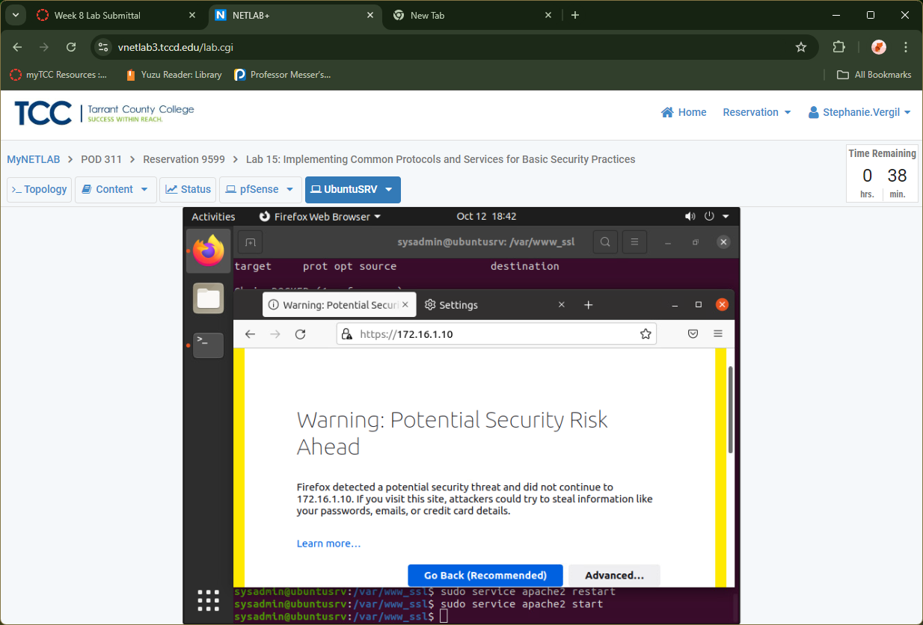
7. When expanded, click on the Accept the Risk and Continue button.
8. Notice the web page with Testing HTTPS Service opens. To view the contents of the server certificate, click the lock icon located to the left of the URL.

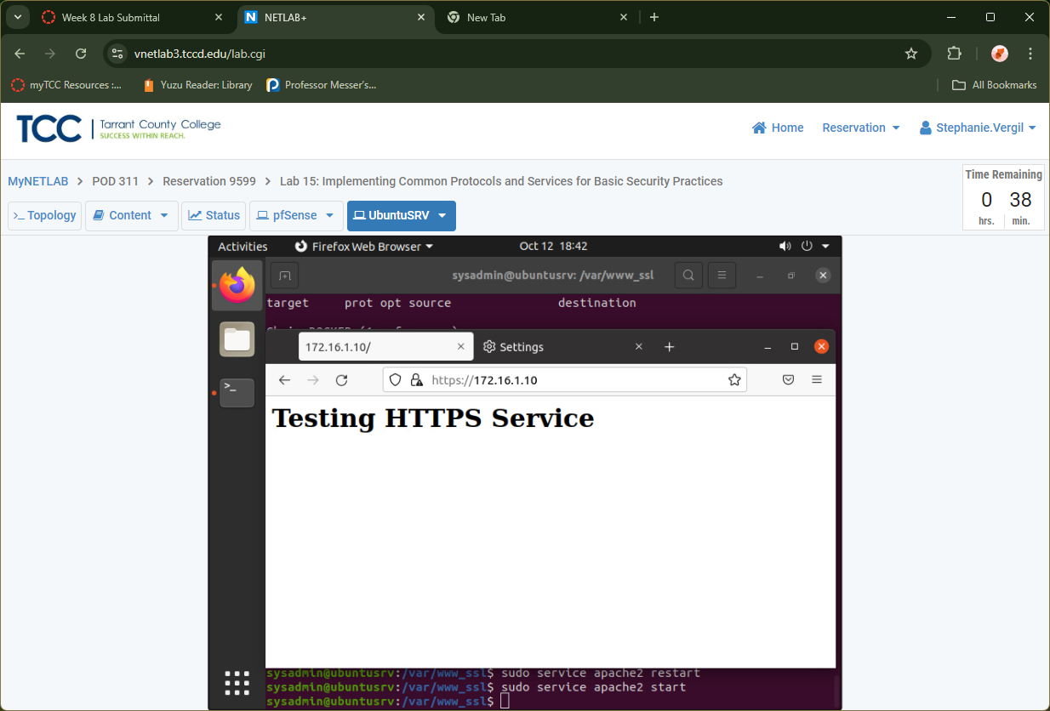

1. A small window will appear. Click on Connection not secure, then click More Information
2. On the Page info screen, notice the Website Identity information. Click the View Certificate button.
3. On the Certificate Viewer window, notice the entries for Issuer Name and the period of Validity. All values are reflective of the contingencies set when the self-sign of the certificate took place at the beginning of Task 2.1.

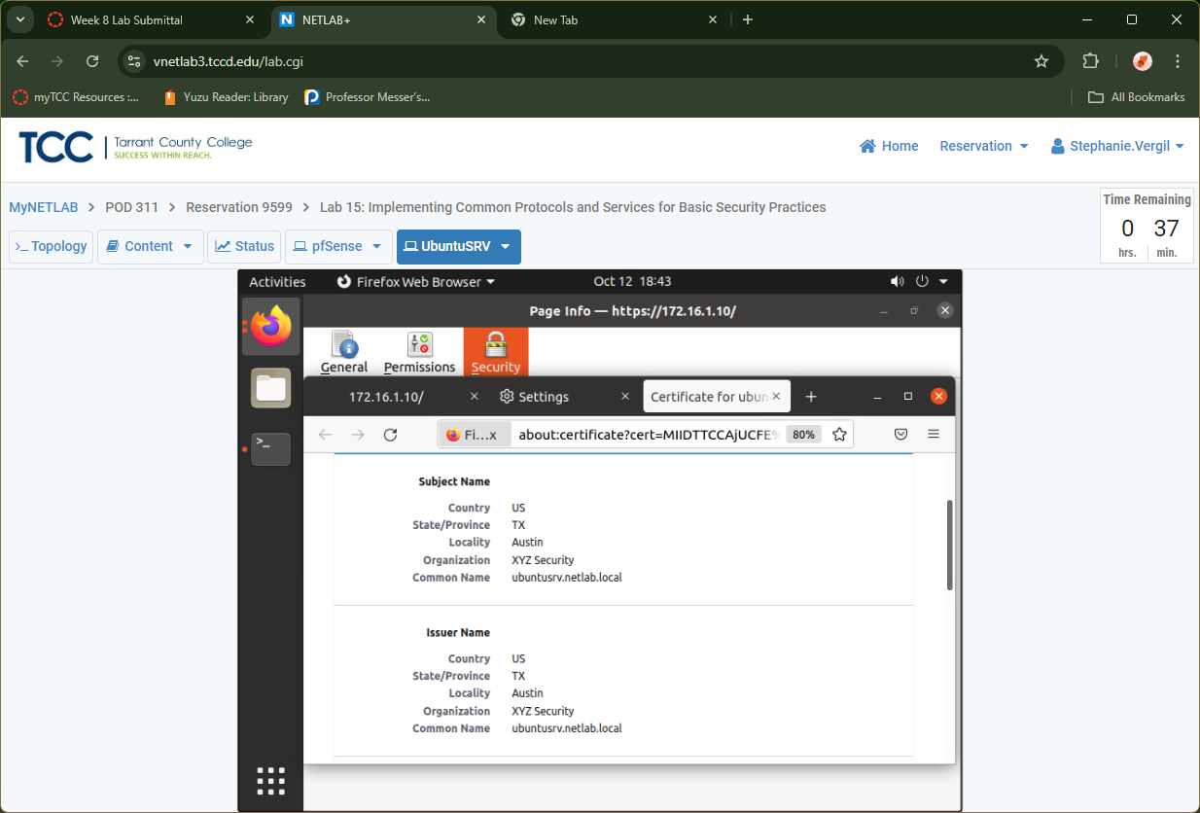

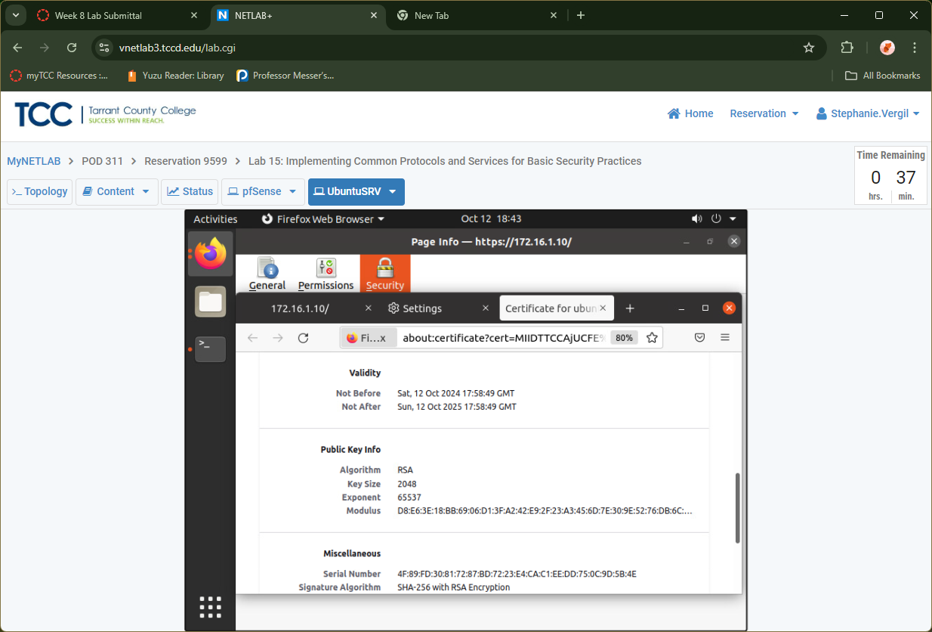

1. Lab Completed.